M1I622938 Coursework

Introduction to Games Programming

*Session 2020 - 2021*

Sam Ivory S2027712 Computer Games (Software Development)

*I confirm that the code contained in this file (other than that provided or authorised) is all my own work and has not been submitted elsewhere in fulfilment of this or any other award*.

Contents

Life system 3

Using tags as an identifier 3

Issues 3

# Life system

To give player lives, first they had to be able to see how many lives they had and to have it come on screen if they lost one. This meant whenever the ball collided with the goal, the value of the ‘lives’ variable decreased.



Code Snippet 1

To show the player how many lives they had, the had the current value of ‘lives’ sent to an UI element which was in the canvas.



Code Snippet 2

The code finds the game object ‘Canvas’ and the UI element ‘Lives’ that is within it. It gets the component that can edit text and changes it to the phrase “Lives Left:” and shows the value of the lives variable.

# Using tags as an identifier

Instead of having a long switch statement to have the bricks despawn when hit, a tag could be applied to all Brick objects which could be used to give all bricks the same commands.

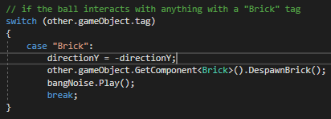

Code snippet 3

When the ball collides with a game object with the tag ‘Brick’, the direction of the ball would change on the Y axis and then find the class ‘Brick’ and call the DespawnBrick function.



Tag applied to an object

# Issues

One difficulty that was encountered